WILLIAM O. WARE LODGE OF RESEARCH

BOOK REVIEW – June 2020

The History of Freemasonry in Kentucky in its Relations to the Symbolic Degrees

Robert Morris PGM – Kentucky, 1858

Published in Louisville, by Rob Morris 1859, 542 pages

Review by Cameron C. Poe, PM

I
n the libraries of masonic scholars across the world, there are likely countless versions of Masonic histories. A compilation of history by Past Grand Master (KY) and Poet Laureate Robert Morris is no exception. Perhaps a more appropriate, although impractical, title could have been “The History of Freemasonry in Kentucky until 1858”.

As Kentucky Masons know, Freemasonry came to Kentucky in 1788 by way of the Grand Lodge of Virginia through Lexington, the most western frontier settlement at the time, consisting of about fifty log cabins according to contemporary sources.

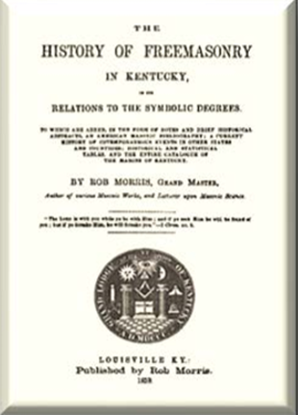
The work itself is comprehensive, rather extensive in some areas and occasionally, oddly lacking in others. Some of the more famous Masonic events in America (Morgan Affair, Anti-Masonic Party platform) from 1800-1850 were not recorded as in-depth as this reader would have liked. But it is the only account of Kentucky Masonic history for the first 70 years compiled in one book, and it is a microcosm into the thoughts of the day regarding where Freemasonry came from and where it was going. With this in mind, Morris points out immediately that he had no predecessor. And he almost apologizes for the excessive references in the preface stating, “If the work appears overloaded with references, it must be attributed to an anxiety to leave a clear path in which future historians may walk with certainty.” From an amateur historian's perspective, the candor with which he presents the history is appreciated.

Morris begins with a history of Freemasonry in England (it arrived in America around 1733) and outlines the expected confusion pertaining to whom or what exactly was in charge. The Grand Lodge of England, Grand Lodge of Scotland (after 1734), and the Grand Lodge of Ireland all played a role in the establishment of Lodges in America even prior to 1733. Morris also describes the lack of historical records by all these organizations when it comes to cataloging the foundation of Freemasonry in America.

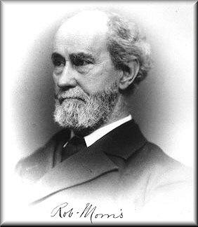
Several pages are spent carefully listing in chronological detail the various Grand Lodges of England, Scotland and Ireland and their Grand Masters, and even some notable events (the birth of George Washington, for example) occurring in America. The United States history begins with the 1st provincial Grand Lodge in North America in Boston in 1777. Listed as the 2nd provincial Grand Lodge formed, Morris references a detailed account of the Grand Lodge of Virginia in 1793 contained in the Ahiman Rezon. He refers to a nine-page explanation of the who, what, when, and where a convention of delegates gathered in 1776 to elect a Grand Master to preside over all Lodges then in the Virginia colony.

Morris continues with a listing of what appears to be all significant events in recorded Masonic history involving Kentucky including the proceedings, ceremonies, adoptions, and even military actions that were relevant at the time. Beginning in 1750 a monthly account of events is detailed.
Following this is an extensive history including the names of those individuals involved, letters, and minutes of meetings surrounding the formation of the Grand Lodge of Kentucky in 1800 that are fascinating in content and historical value.

Once again, Morris puts the information in chronological order by decade beginning with the proceedings from 1800-1809 of the Grand Lodge of Kentucky, with references including the reasons they decided to split from Virginia, and Virginia’s response to the request.

Morris continues with the establishment of the adopted lectures and ritual presenting evidence that “the first knowledge of Masonry in Kentucky was brought from Virginia, that everything Masonic, printed and unprinted which emanated from Virginia was adopted without question, as the law of Kentucky.” Morris also takes this opportunity to point out that the quality of work in Kentucky had declined since its inception.

Morris details for the remainder of the work the proceedings of the Grand Lodge of Kentucky with “Contemporary Events” also a part of the record. Many of these are fascinating to read if one has even the slightest interest in Masonic history. One of the largest events covered in depth is the death of Col. Joseph Hamilton Daviess, sitting Grand Master of Kentucky in 1812. A lengthy account of the events leading up to and including the Battle of Tippecanoe is explained, as well as the reaction across the country to the news. The Grand Lodge of Indiana had not yet been established so it is pointed out that Daviess was also Grand Master in the Indiana territory at the time. His heroic actions on the battlefield were echoed throughout the fraternity in many jurisdictions.

Morris also points out important events in other Grand Lodge jurisdictions including some disciplinary actions of Masons, explanations of un-Masonic conduct, and other rulings made by Grand Lodges etc. These accounts lead right up to his election as Grand Master of Kentucky in 1858.

The “Historical Register” of Lodges in Kentucky begins on page 455 of the work. Some more notable members of particular Lodges are given a brief biography. The roster of Lodges begins with Lexington Lodge No. 1 and ends with Baltimore Lodge No. 360. An additional five Lodges listed as under dispensation.

Also included is the “Jurisprudence of the Grand Lodge of Kentucky” showing when each clause and constitutional rule was adopted for the government of subordinate Lodges up to and including the year 1858. He concludes with “Rules of Order” which should be required reading for most Masons of today as it is still applicable to the conduct of a Masonic lodge. Morris capstones the work with resolutions adopted in 1858 and a catalog of membership in alphabetical order and the Lodge to which they belonged. I am certain this was included for reference only.

As a historical work, this is an invaluable resource for any Masonic historian, more especially one interested specifically in Kentucky Freemasonry. The detail in which Morris also addresses the formation and proceedings of other Grand Jurisdictions cannot be understated.

Ironically, the original publication was not well received and sold very few copies, I suspect due to its lack of a “story,” and perhaps due to its size (over 500 pages). Morris presents factual evidence, not a running commentary on those facts. In a few areas, though, he cannot help himself and interjects his own thoughts on some topics.

Also, to take into consideration is that perhaps the general level of education at the time prevented it from being widely distributed. At any rate, relevant occurrences in the formation of Freemasonry in Kentucky are prevalent throughout the work and Morris references that he hoped this compilation would inspire other Grand Lodges to record their histories. If this is an example of what a history can be from the time, I sincerely hope they considered his advice.

Overall, The History of Freemasonry in Kentucky in its Relations to the Symbolic Degrees is an excellent reference for the Masonic historian as well as the curious non-Mason.

Reviewed by:
Cameron C. Poe, P. M.

Cameron C. Poe is a Past Master of Lexington Lodge No. 1 and a member of William O. Ware Lodge of Research. He is a Fellow of The Masonic Society and a co-founder and past chairman of The Rubicon Masonic Society. W. B. Poe has served as District Deputy Grand Master (District 20), Assistant Grand Tyler of the Grand Lodge of Kentucky and has served on several Grand Lodge Committees, including the Chairmanship of the Grand Lodge’s Committee on Masonic Education. He is the author of numerous papers on Freemasonry, many of which may be found in the Articles/Essays/Commentaries section of this website.

